**Class Diagram**

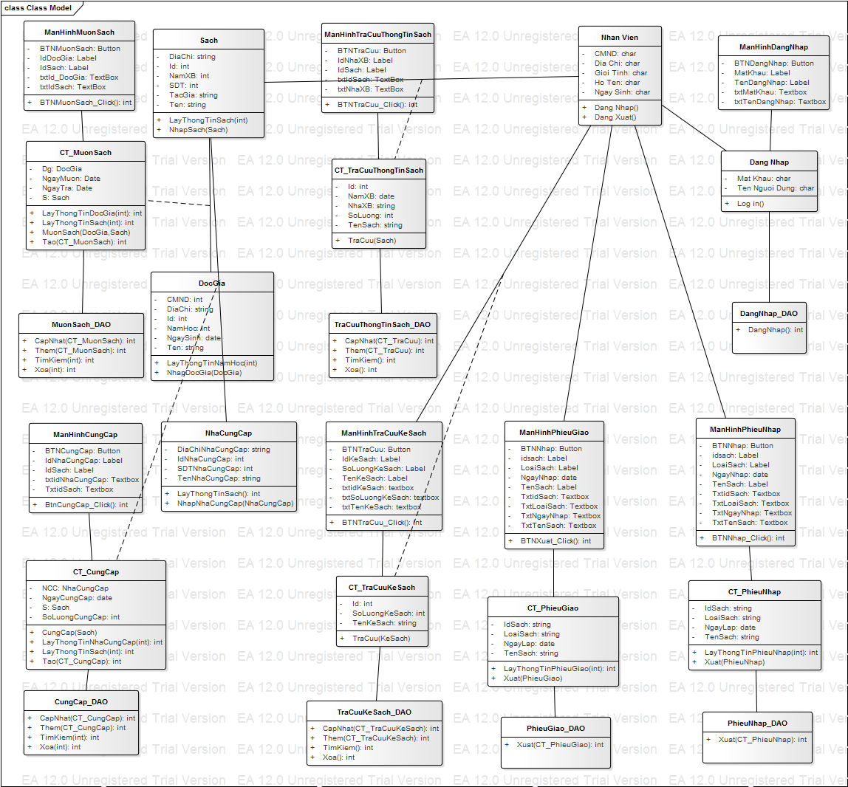

[**Sequence Diagram**](https://courses.fit.hcmus.edu.vn/mod/assign/view.php?id=23670)

**1.**[**Sequence Diagram**](https://courses.fit.hcmus.edu.vn/mod/assign/view.php?id=23670) **Mượn Sách**

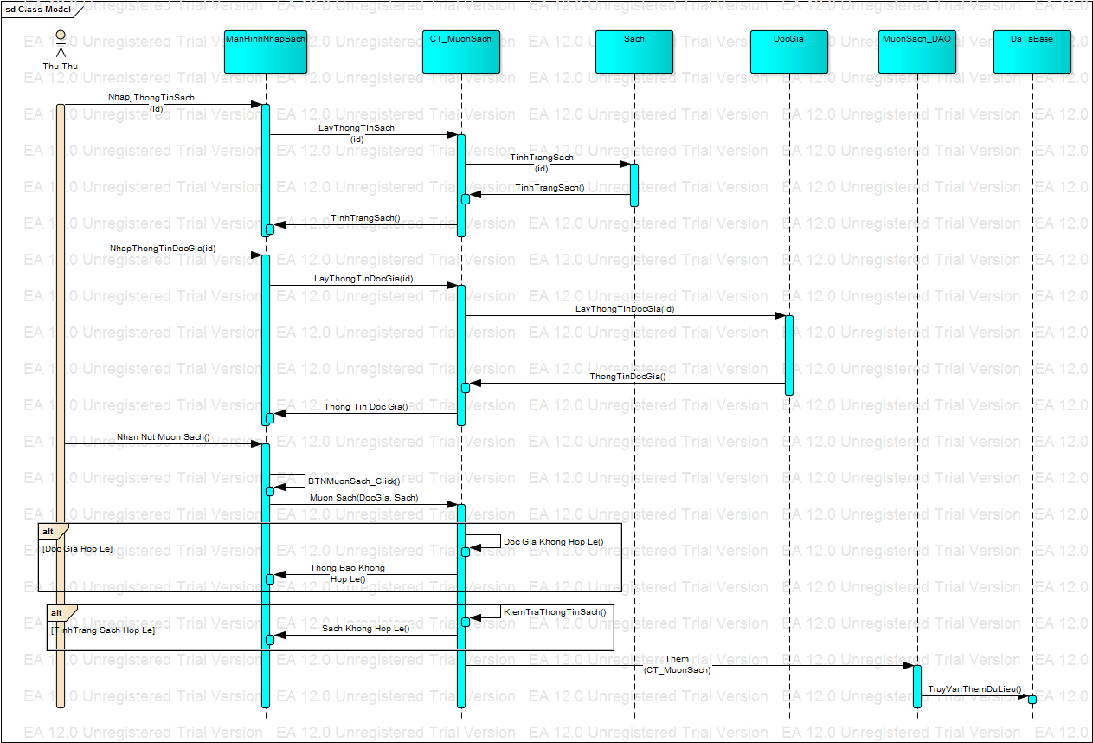

[**Sequence Diagram**](https://courses.fit.hcmus.edu.vn/mod/assign/view.php?id=23670) **Tra Cứu Kệ Sách**

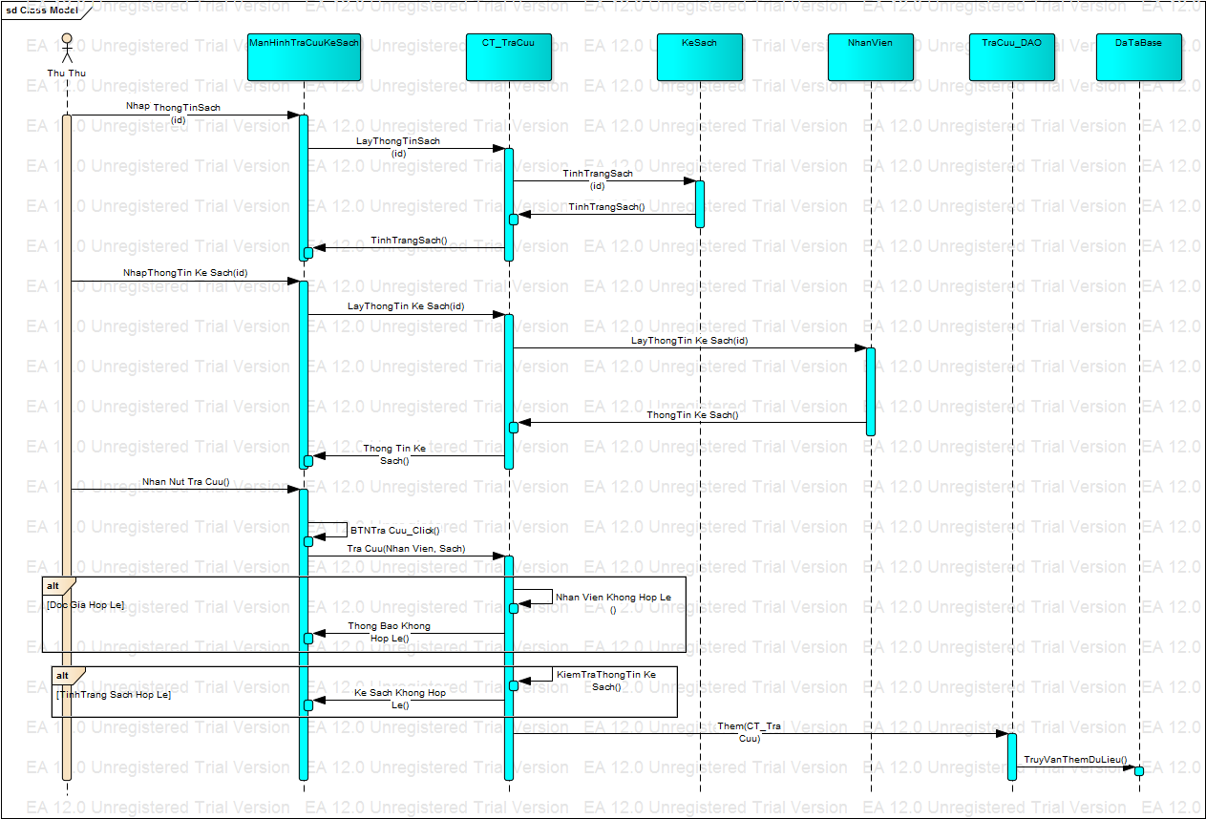

[**Sequence Diagram**](https://courses.fit.hcmus.edu.vn/mod/assign/view.php?id=23670) **Tra Cứu Thông Tin Sách**

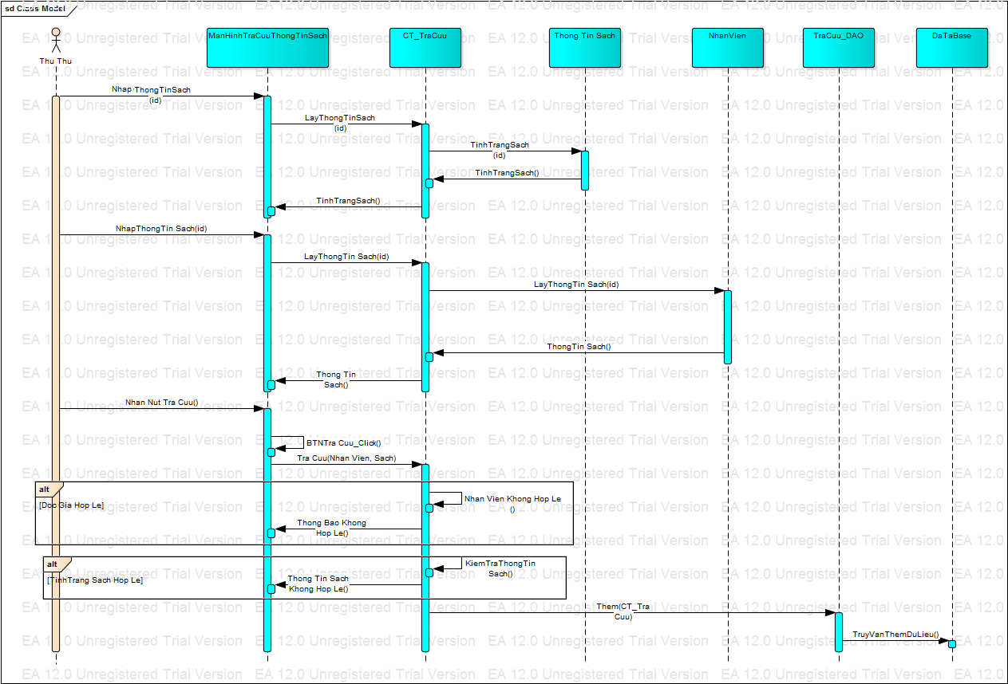

[**Sequence Diagram**](https://courses.fit.hcmus.edu.vn/mod/assign/view.php?id=23670) **Nhà Cung Cấp**

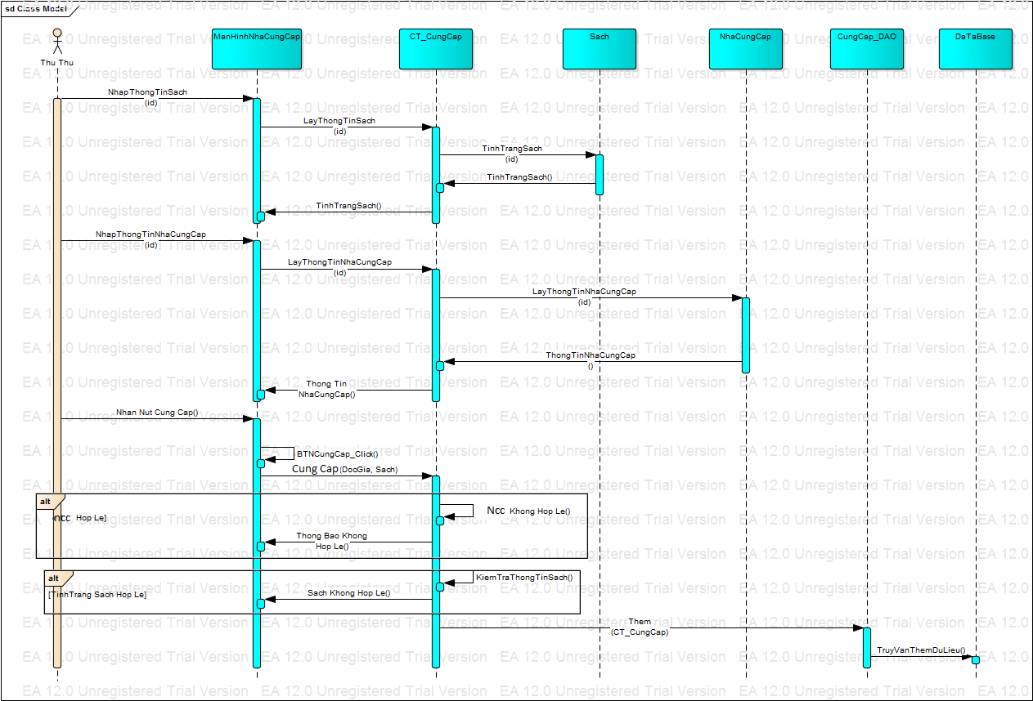

[**Sequence Diagram**](https://courses.fit.hcmus.edu.vn/mod/assign/view.php?id=23670) **Phiếu Nhập**  
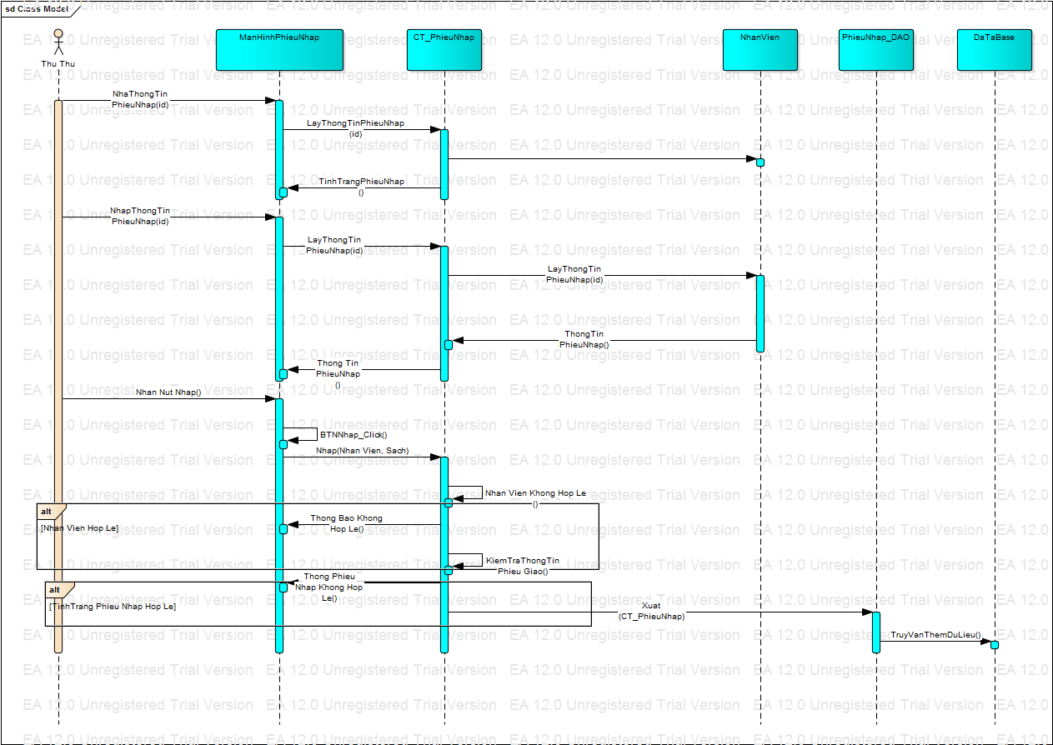

[**Sequence Diagram**](https://courses.fit.hcmus.edu.vn/mod/assign/view.php?id=23670) **Phiếu Giao**

